Campus Dormitory Cleaning Platform Validation Report
Result The test supports recurring paid demand for dormitory cleaning, but only partially supports switching from private WeChat booking to a platform. All documented users already paid RMB 40 per hour for two hours, while two users would consider a platform trial only after roommate approval.

1 Critical Hypothesis
Hypothesis Students in shared dormitories will adopt a campus cleaning platform if it provides transparent prices, defined service scope, verified cleaners and reliable quality. The riskiest assumption is platform switching, because paid cleaning already occurs through private WeChat contacts.

2 Target Users and Recruitment Criteria
Target users Students living in multi-person dormitories who had paid for cleaning, experienced a recent shared-area cleaning problem or participated in the dormitory purchase decision. Evidence includes three documented WeChat interviews and internal dormitory group notes.

3 Test Method and Main Metric
Method Semi-structured interviews covered recent incidents, current cleaning arrangements, actual price and frequency, desired service scope, concerns and willingness to join an RMB 80 trial. The main metric was a concrete next step: discussing the trial with roommates and confirming a service time.

4 Pre-set Success and Failure Threshold
Continue if at least three target users show repeated paid behavior or recurring pain, and at least two agree to take the proposal to their roommates. Rethink if most users have no recurring need or nobody takes a next step beyond saying that the idea sounds useful.

5 Raw Results and Key Evidence
Record | Observed behavior | Platform response
A | Private WeChat cleaner every 2-3 weeks; RMB 80 for two hours; eight students split RMB 10 each. | Values transparency; conditional trial interest pending roommate approval.
B | Calls a cleaner when needed; an earlier duty arrangement faded because execution was weak. | Wants transparent price, scope and credentials; no immediate trial need.
C | Cleaner every two weeks; a missed duty recently caused overflowing rubbish and insects. | Wants price and quality assurance; conditional trial interest pending roommate approval.
Group notes | Cleaner every three weeks; a failed duty roster led to free-riding, conflict and strained relations. | One request for bedding and private-room help; no recorded trial commitment.

6 What the Evidence Supports and Does Not Support
Supported Recurring paid demand, an observed reference price of RMB 80 per visit, public shared areas as the core service, bill splitting, and the value of transparent price, scope, identity and quality information.
Not yet supported A completed platform booking, repeated platform use, sustainable platform margin or broad demand for private-room services. Some users reported no serious problem with their current private arrangement.

7 Next Decision
Decision Run one concierge trial at the existing RMB 80 price before building the platform. Offer public-area cleaning only and show the cleaner's identity, price, scope, duration and quality policy. Continue to a focused product only after one dormitory approves and completes an order and shows repeat intent.

Appendix Anonymized Interview Evidence
Contact names, avatars and device-status information have been permanently removed. The excerpts retain the interview content and message order.

Dormitory Group Notes
The dormitory hires a cleaner about once every three weeks at RMB 40 per hour for two hours. A previous duty roster failed because tasks were not completed consistently and some residents avoided their share, which caused conflict and strained relationships. One resident requested private-room services such as handling quilts and bed sheets. These are field notes because no chat screenshot was retained.

Interviewee A
Existing private WeChat booking every two to three weeks; RMB 80 for a two-hour shared-area service; an eight-person dorm splits RMB 10 each. The participant values transparent information and would consider a trial after roommate approval.
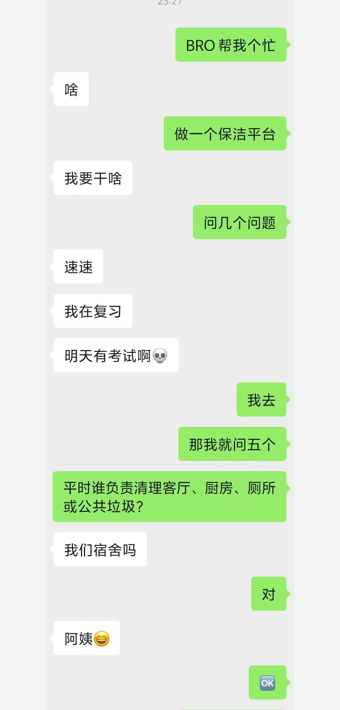  Anonymized chat excerpt 1 | 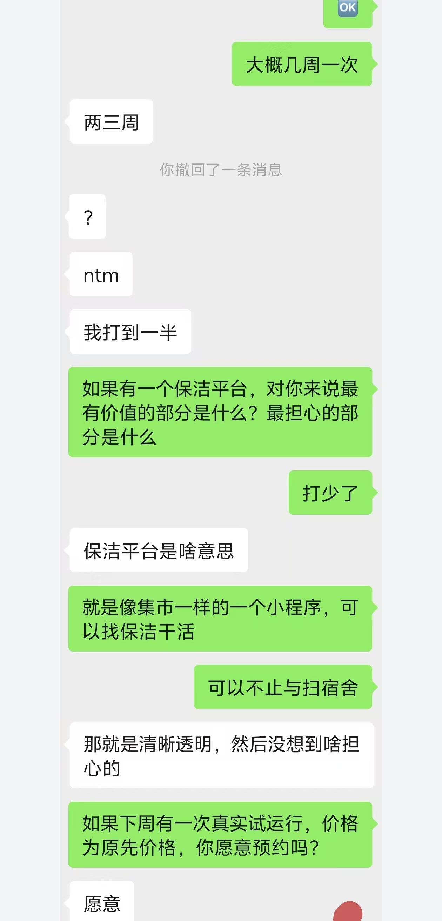  Anonymized chat excerpt 2

Interviewee B
The dorm calls a cleaner when the shared space becomes sufficiently dirty. An earlier duty arrangement faded because execution was weak. The participant values transparent pricing, service scope and provider credentials, but reported no immediate need for a trial.
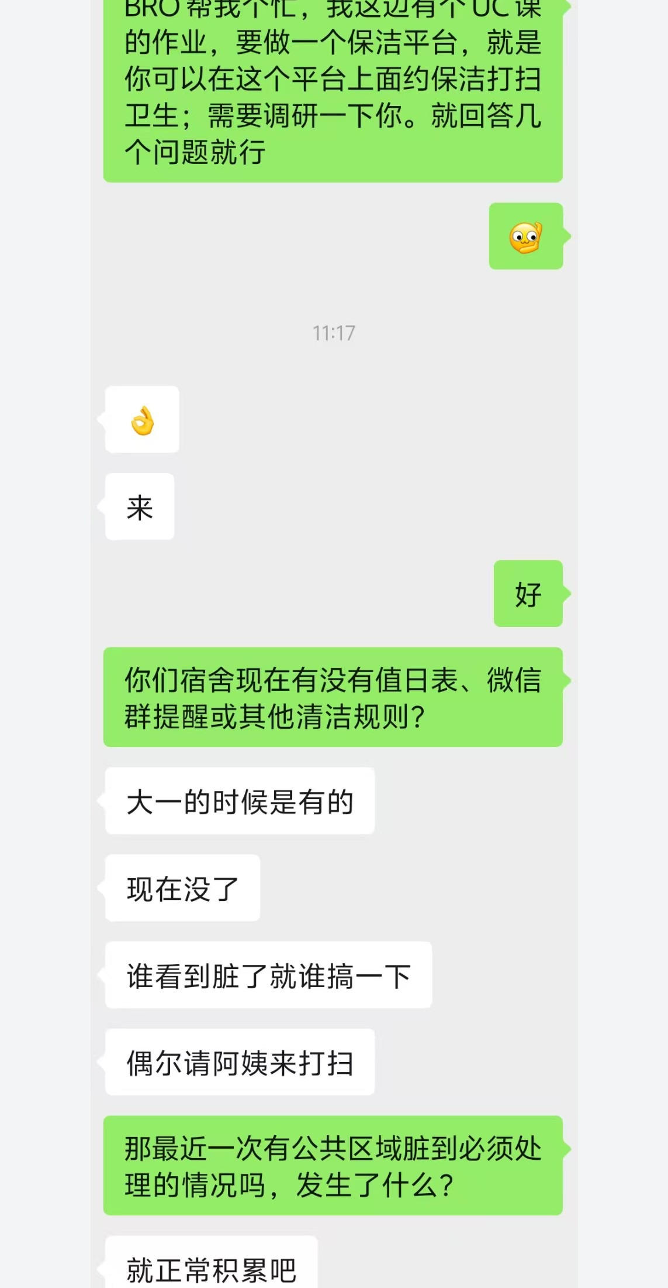  Anonymized chat excerpt 1 | 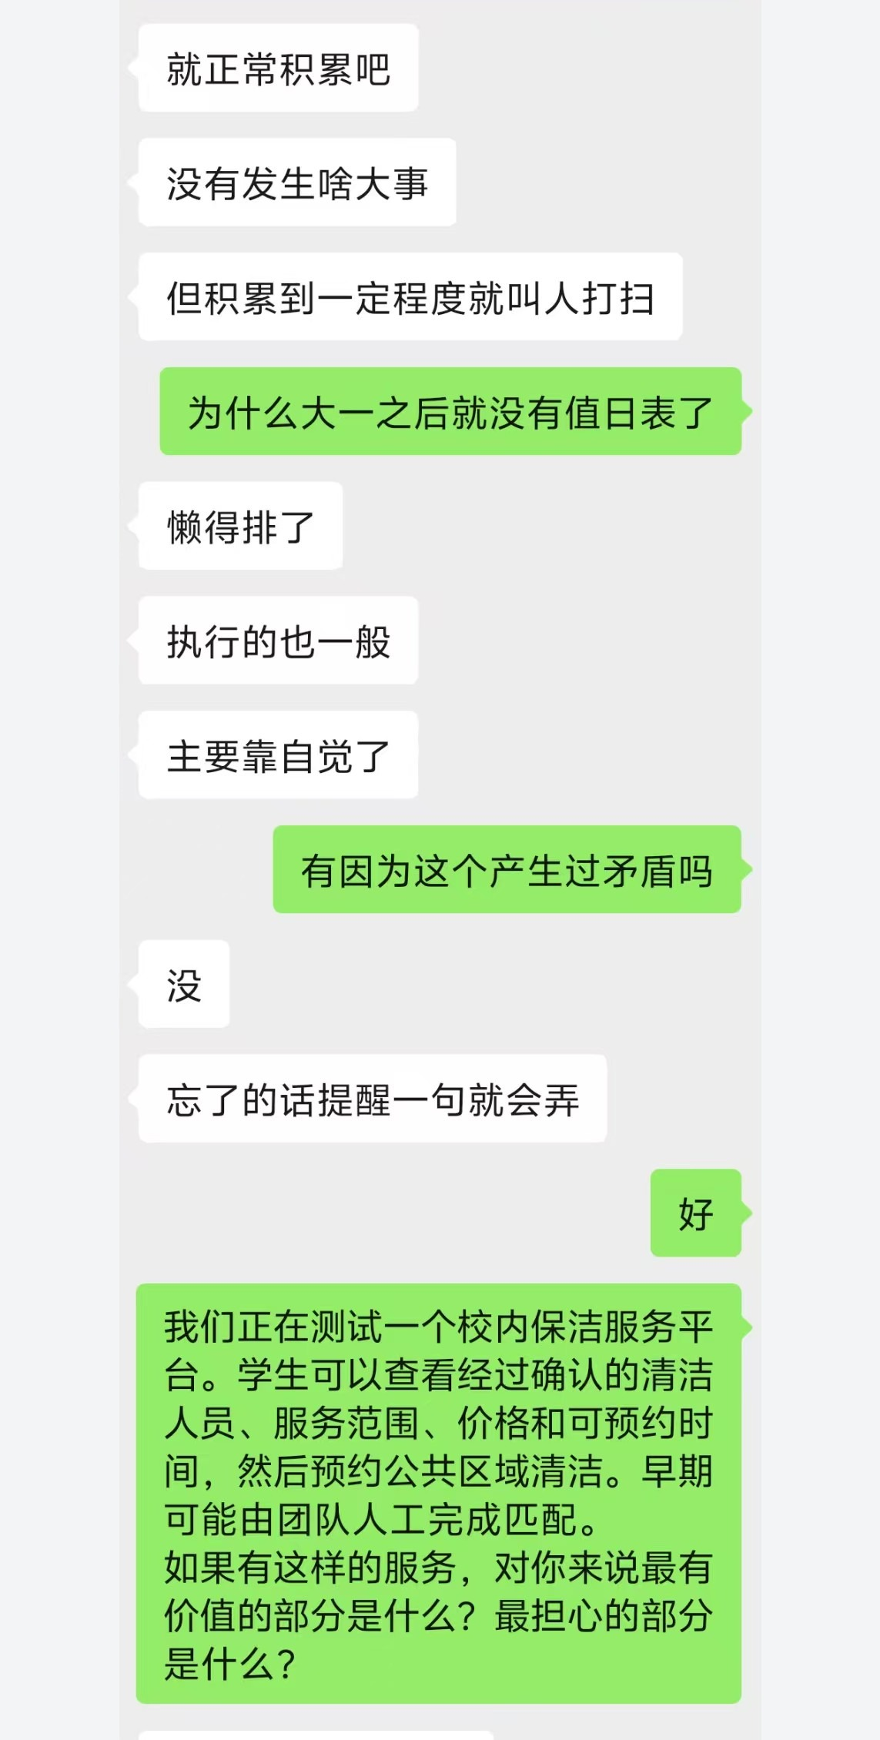  Anonymized chat excerpt 2

Interviewee B Continued
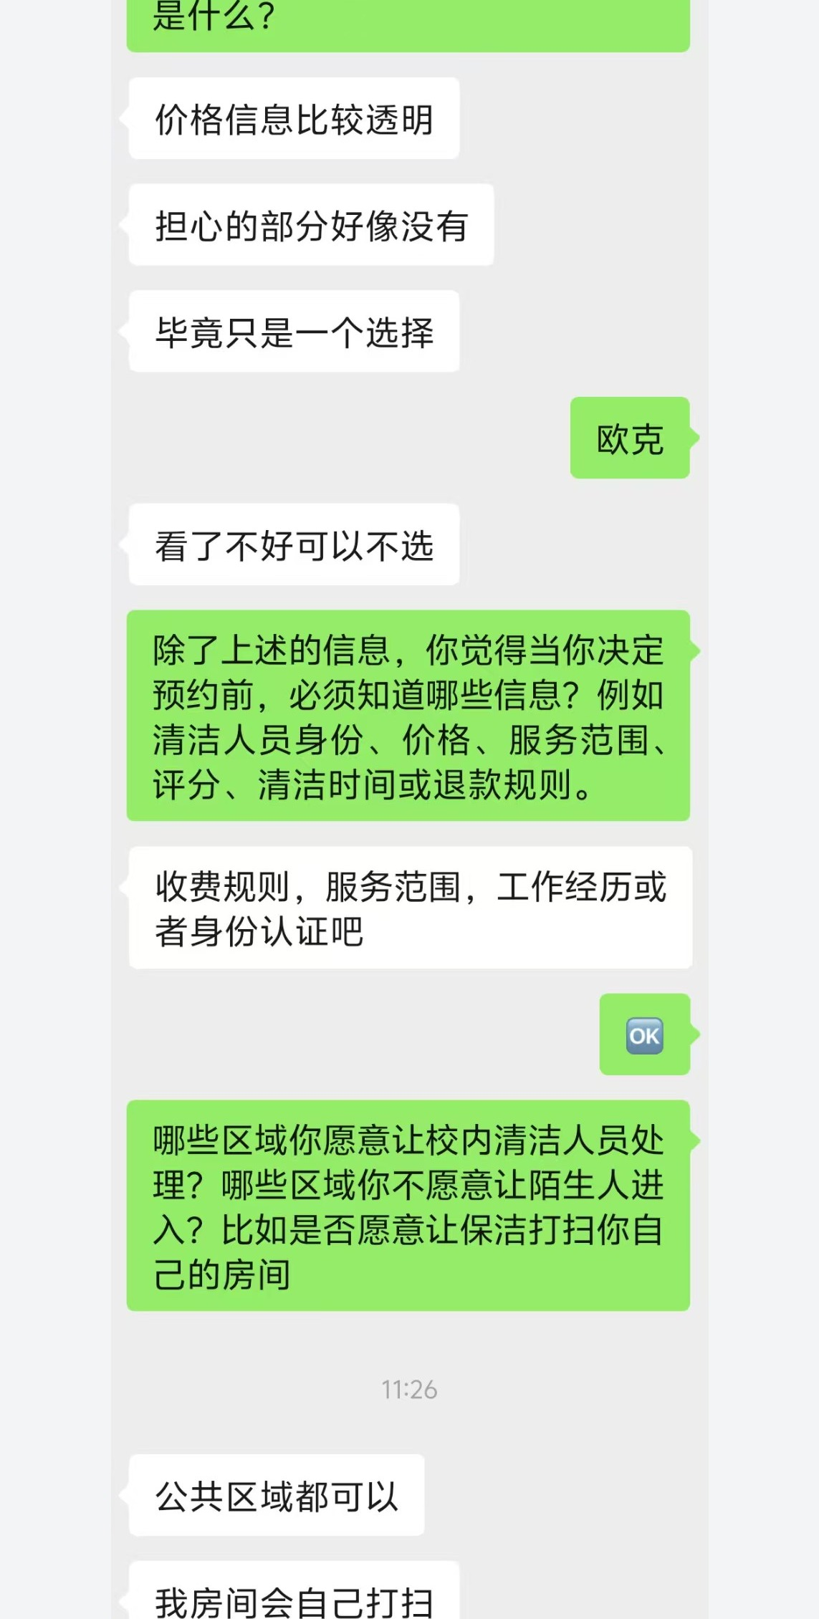  Anonymized chat excerpt 3 | 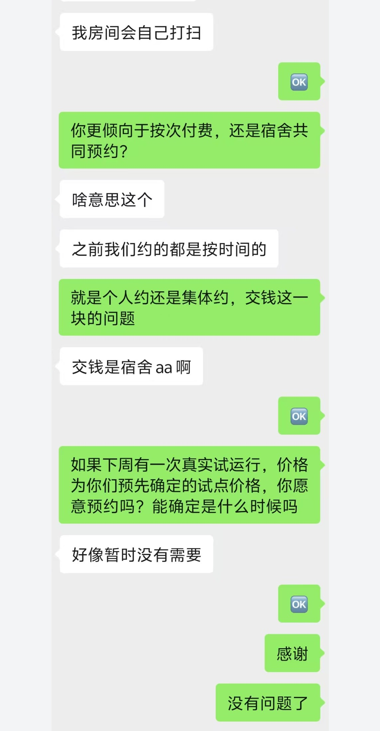  Anonymized chat excerpt 4

Interviewee C
The dorm hires a cleaner every two weeks. A recent missed duty caused overflowing rubbish, a worse living environment and insects. The participant cares about price and cleaning quality and would try the RMB 80 service after roommate approval.
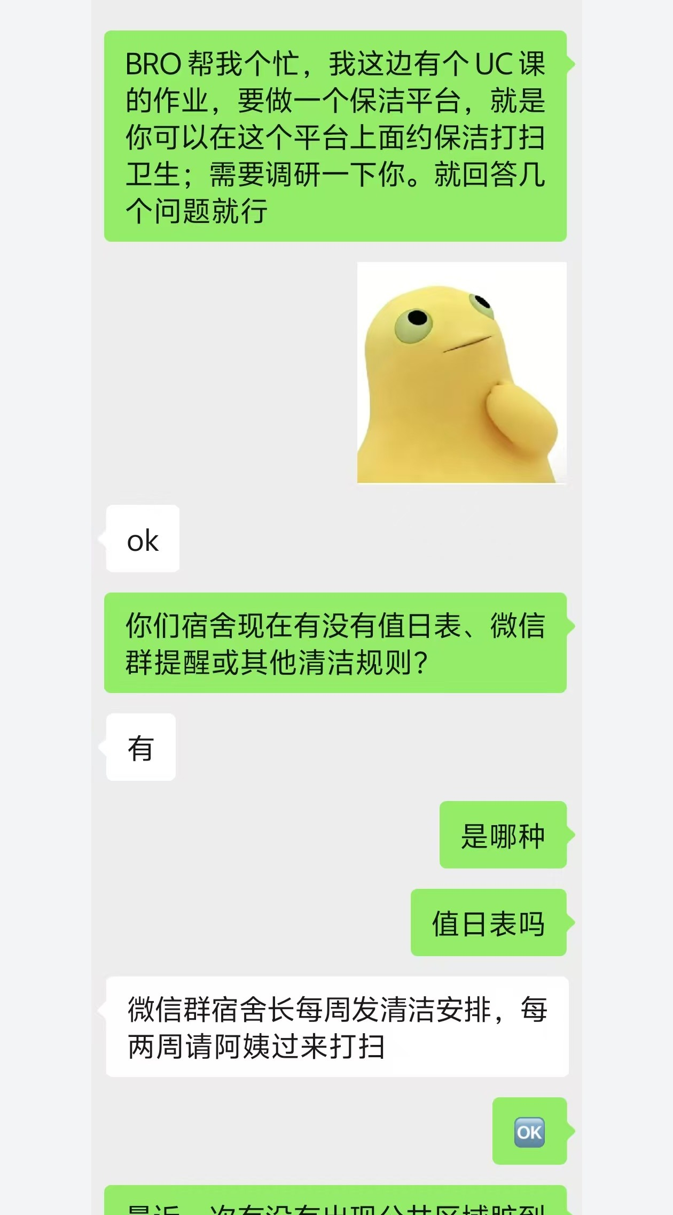  Anonymized chat excerpt 1 | 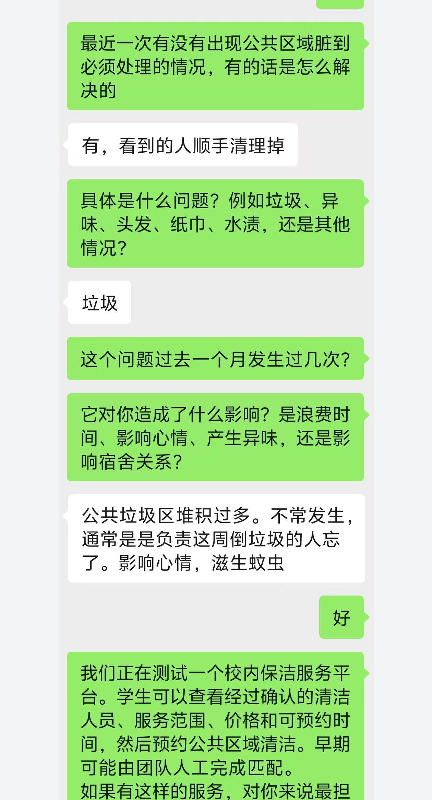  Anonymized chat excerpt 2

Interviewee C Continued
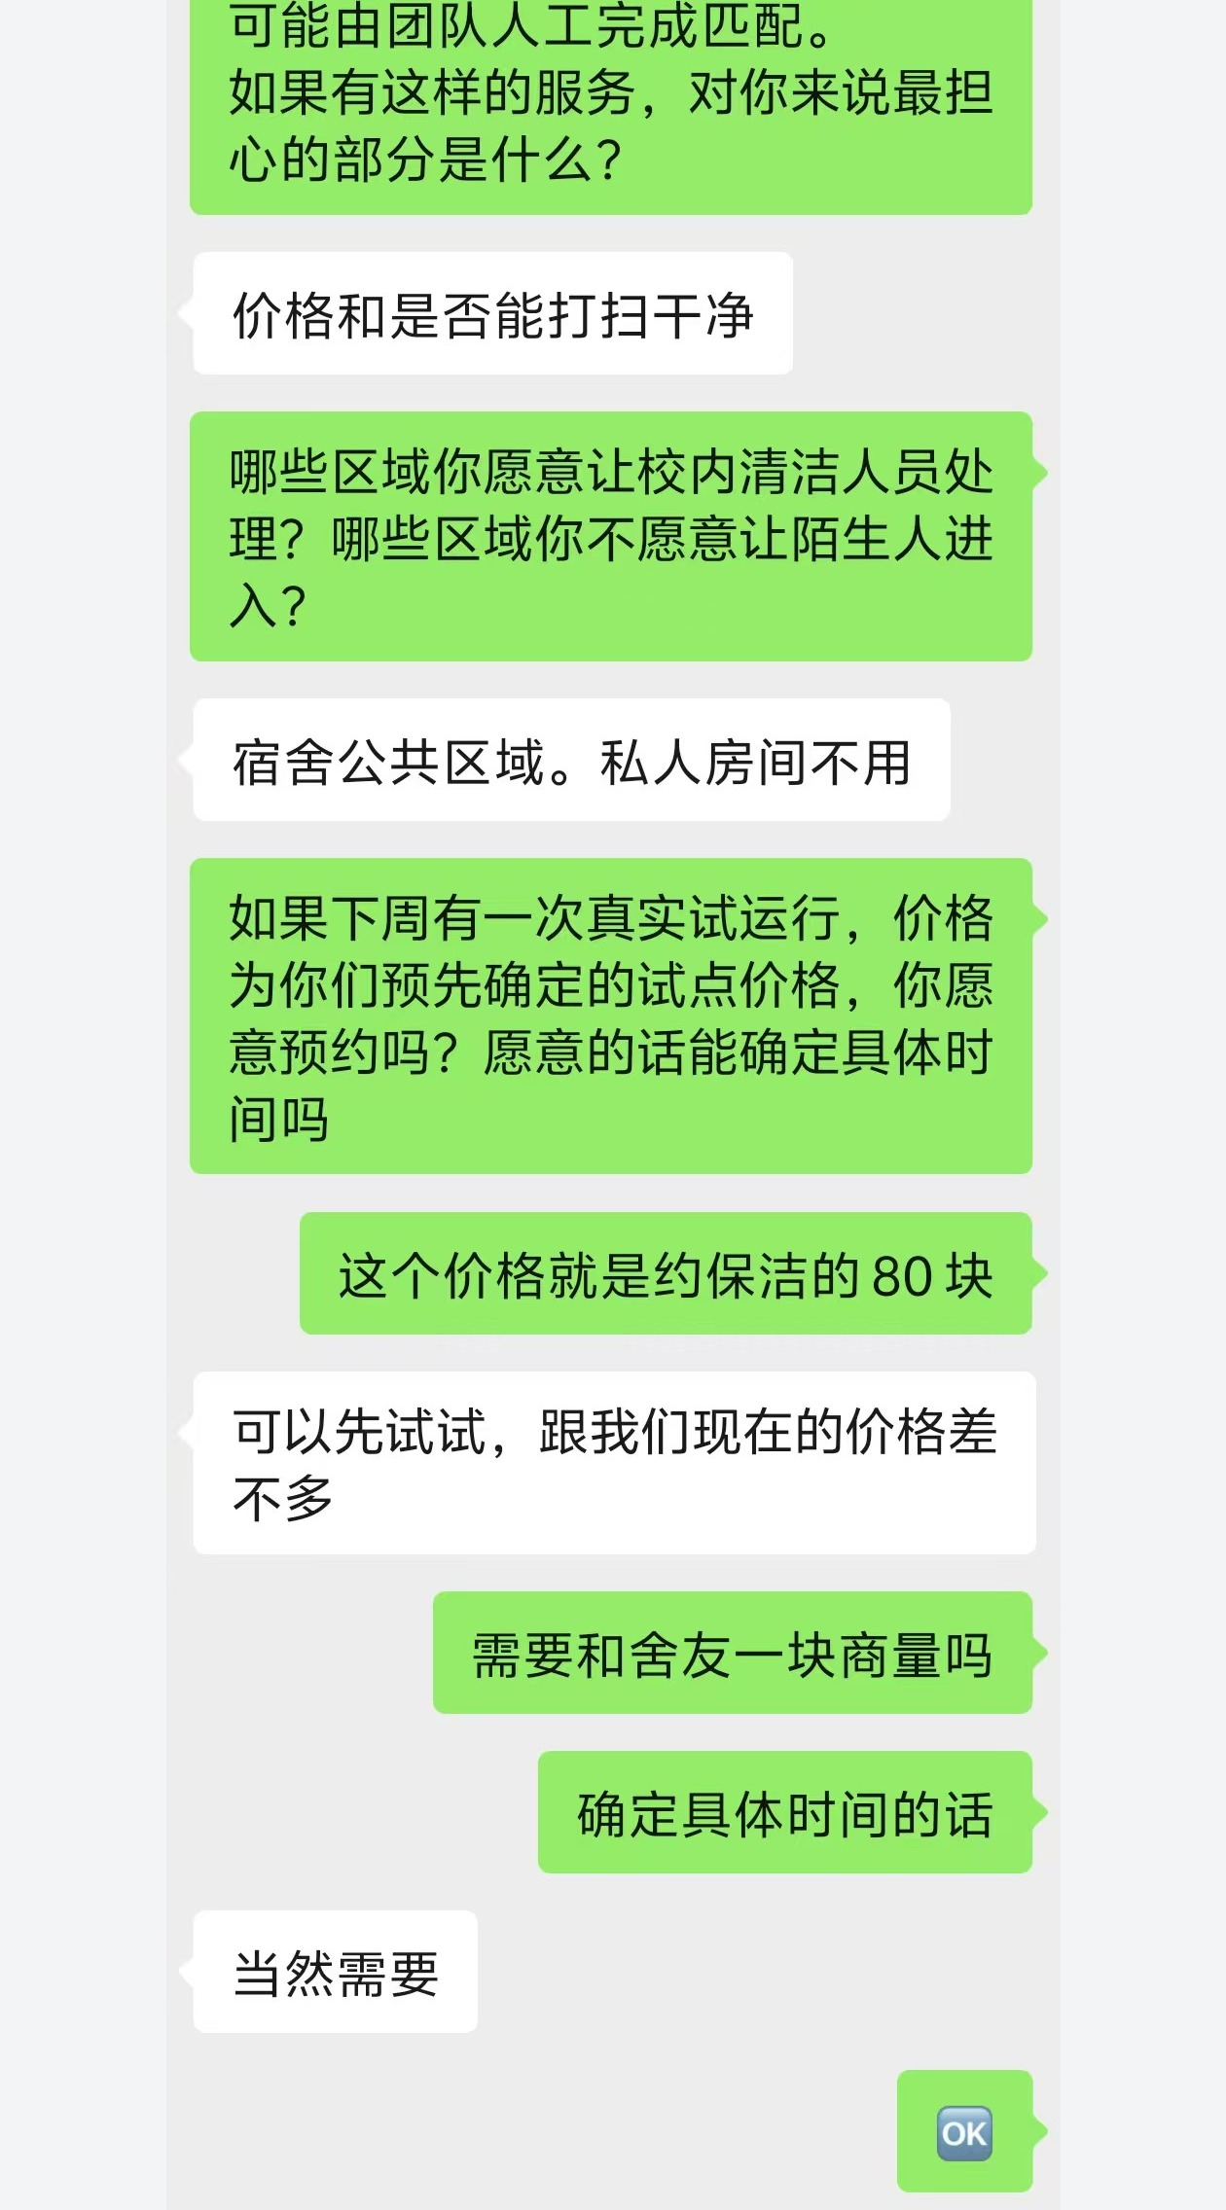
Anonymized chat excerpt 3

